Addiscombe Cycling Club
Open 10 mile Time Trial
For the Arthur Rayner Trophy
(Promoted for and on behalf of Cycling Time Trials under their Rules and Regulations)
14:00 Saturday July 27th 2018 – Course G10/42
Event Record: 19:45 Pat Wright 2018 @ 30.38 Mph
HQ: St. Johns Primary School
Goodwyns Rd, Dorking, RH4 2LS
Promoter Name: Ian Bray
Address: 22 Purley Bury Close, Purley, Surrey, CR8 1HU
Tel: 07940346263
Email: open10@addiscombe.org
Timekeepers: Peter Delve & Mick Irons
Course Details:
OS Ref | Details | Distance
167469 | START in Spook Hill, North Holmwood at PO Telephone Inspection Cover 30 yards from junction with A24  Proceed to A24 where LEFT (care). Proceed South | 0.0
177428 | Take 2nd exit at Beare Green roundabout and follow Capel bypass (A24) | 2.67
171397 | TURN Take 5th exit on Clark’s Green roundabout (check) | 4.91
177428 | Take 2nd exit straight on at Beare Green Roundabout | 7.15
166472 | FINISH at drain at North end of penultimate crash barrier 634 yards from North Holmwood roundabout | 10.00

Live timings: To check live timings please use this link, pass to family and friends if required.

https://www.hundredthidiot.co.uk/tt/public/results/3
SAFETY INSTRUCTIONS
- Competitors are requested not to warm up on the course after the first competitor has started.
- Details of any additional hazards not listed on the start sheet will be displayed or advised at the Signing On point. All competitors must take note of these details when they sign on.
- Competitors must exercise extra care when negotiating all roundabouts.
- No times will be given at the finish.
- CTT regulations require the compulsory use of helmets for the under 18’s. In the interests of your own safety, Cycling Time Trials and the event promoters strongly advise all competitors to wear a hard/soft shell helmet that meets internationally accepted safety standards.
- Competitor’s machines: it is recommended that a working rear light, either flashing or constant, is fitted to the machine in a position clearly visible to following road users and is active while the machine is in use.
- Any participants under the age of 18 are required to present their completed parental consent form at the sign-on desk. No helmet, no parental consent then no ride.
HEADS UP, RIDE SAFELY!
Prizes
Scratch: 1st £40 2nd £20 3rd £10
Lady’s: 1st £40 2nd na 3rd na
Veterans: 1st £40 2nd £20 3rd £10
Road bike: 1st£40 2nd£20 3rd £10
Team: 1st £60

The scratch winner will also receive the Arthur Rayner trophy so please hang around for the award ceremony around 15.30pm
For final results and prizes check:

https://www.hundredthidiot.co.uk/tt/public/results/3
Notes on prizes:
- One prize per rider except for the Team prize the highest value prize being paid.
- A Team is the fastest 3 riders from a single club / team.
- Any unclaimed prizes will be donated to Addiscombe CC
Start sheet page 1:

Start No. | Start time | First name | Last name | Club | Gender | Category
1 | 14:01 | Rachel | Eaton | Addiscombe CC | Female | Veteran
2 | 14:02 | Pippa | Crouch | Crawley Wheelers | Female | Veteran
3 | 14:03 | Mark | Houlden | 34 Nomads CC | Male | Veteran
4 | 14:04 | Peter | King | Leetl Donki CC | Male | Veteran
5 | 14:05 | Michael | Porter | 34 Nomads CC | Male | Veteran
6 | 14:06 | Christian | Yates | East Grinstead CC (Merlin Cycle Coaching) | Male | Veteran
7 | 14:07 | Brian | Jones | Horsham Cycling | Male | Veteran
8 | 14:08 | David | Mulford | Sydenham Whs | Male | Veteran
9 | 14:09 | Jonathan | Gough | Old Portlians CC | Male | Senior
10 | 14:10 | Mark | Bashford | East Grinstead CC (Merlin Cycle Coaching) | Male | Senior
11 | 14:11 | John | Glaysher | ...a3crg | Male | Veteran
12 | 14:12 | Jed | Rock | Dorking Cycling Club | Male | Veteran
13 | 14:13 | Charlotte | Roberge | Dulwich Paragon CC | Female | Veteran
14 | 14:14 | John | Froud | Festival Road Club | Male | Veteran
15 | 14:15 | Neal | Beauchamp | Rapha Cycling Club | Male | Senior
16 | 14:16 | Jonathan | Pontin | Addiscombe CC | Male | Senior
17 | 14:17 | Mike | Boyce | ...a3crg | Male | Veteran
18 | 14:18 | Christopher, | Rosam | Epsom CC | Male | Veteran
19 | 14:19 | Andrew | Nippard | Pearson Cycling Club | Male | Senior
20 | 14:20 | Simon | Church | trainSharp | Male | Veteran
21 | 14:21 | Ian | Bray | Addiscombe CC | Male | Senior
22 | 14:22 | Steve | Mansfield | Kingston Wheelers CC | Male | Senior
23 | 14:23 | John | Franklin | Twickenham CC | Male | Senior
24 | 14:24 | Tom | Pemberton | New Malden Velo | Male | Senior
25 | 14:25 | Andy | Pearson | Pearson Cycling Club | Male | Veteran
26 | 14:26 | Jim | Ford | Horsham Cycling | Male | Veteran
27 | 14:27 | Matt | Williams | Peckham Cycling Club | Male | Veteran
28 | 14:28 | Ben | Fielden | GS Stella | Male | Veteran
29 | 14:29 | Peter | Adams | Tri Surrey | Male | Veteran
30 | 14:30 | Stuart | Stow | Twickenham CC | Male | Veteran

Start sheet page 2:
Start No. | Start time | First name | Last name | Club | Gender | Category
31 | 14:31 | Alex | Ioannides | Dulwich Paragon CC | Male | Senior
32 | 14:32 | David | Marshall | Hemel Hempstead CC | Male | Veteran
33 | 14:33 | Colin | Gray | Norwood Paragon CC | Male | Veteran
34 | 14:34 | Gary | Holder | VTTA (Surrey/ Sussex) | Male | Veteran
35 | 14:35 | David | Triska | Team Bottrill | Male | Senior
36 | 14:36 | Robert | Gilmour | Hounslow & District Whs | Male | Veteran
37 | 14:37 | James | Cheeseman | N+1 - Lindfield Coffee Works | Male | Senior
38 | 14:38 | Robert | Royle-evatt | Addiscombe CC | Male | Veteran
39 | 14:39 | Barry | Packman | Dorking Cycling Club | Male | Veteran
40 | 14:40 | Jon | Hughes | Velo Club Godalming & Haslemere | Male | Veteran
41 | 14:41 | Chris | Lord | Brighton Excelsior CC | Male | Veteran
42 | 14:42 | Lewis | Roberts | Team PedalRevolution.co.uk | Male | Senior
43 | 14:43 | Mark | Van Niekerk | Dorking Cycling Club | Male | Veteran
44 | 14:44 | Tom | Meakin | Peckham Cycling Club | Male | Senior
45 | 14:45 | Dave | Dawkins | Portsmouth North End CC | Male | Veteran
46 | 14:46 | Colin | Barton | Worthing Excelsior CC | Male | Veteran
47 | 14:47 | David | Hemming | VTTA (Kent) | Male | Veteran
48 | 14:48 | James | Cambourne | Islington Cycling Club | Male | Veteran
49 | 14:49 | Daniel | Quinn | South London Harriers | Male | Senior
50 | 14:50 | Thomas | Whatley | Paceline RT | Male | Senior
51 | 14:51 | Kevin | Nelson | Crawley Wheelers | Male | Senior
52 | 14:52 | Jon | Fry | Horsham Cycling | Male | Veteran
53 | 14:53 | Simon | Pontin | Addiscombe CC | Male | Senior
54 | 14:54 | Steve | Birchall | Crawley Wheelers | Male | Veteran
55 | 14:55 | Michael | Renardson | trainSharp | Male | Junior
56 | 14:56 | Nolan | Heather | Worthing Excelsior CC | Male | Veteran
57 | 14:57 | Stephen | Morgan | Tooting BC | Male | Veteran
58 | 14:58 | Robyn | Yates | Addiscombe CC | Female | Veteran
59 | 14:59 | Keith | White | Epsom CC | Male | Veteran
60 | 15:00 | Adam | Bidwell | Kingston Wheelers CC | Male | Veteran
61 | 15:01 | Mirza | Beg | Dulwich Paragon CC | Male | Senior
62 | 15:02 | Andy | Appleyard | 34 Nomads CC | Male | Veteran
63 | 15:03 | Mark | Brambleby | Northover VT / Rudy Project / SCS | Male | Veteran
64 | 15:04 | Simon | Holder | VTTA (London & Home Counties) | Male | Veteran
65 | 15:05 | Colin | Mcdermott | Festival Road Club | Male | Veteran

Maps
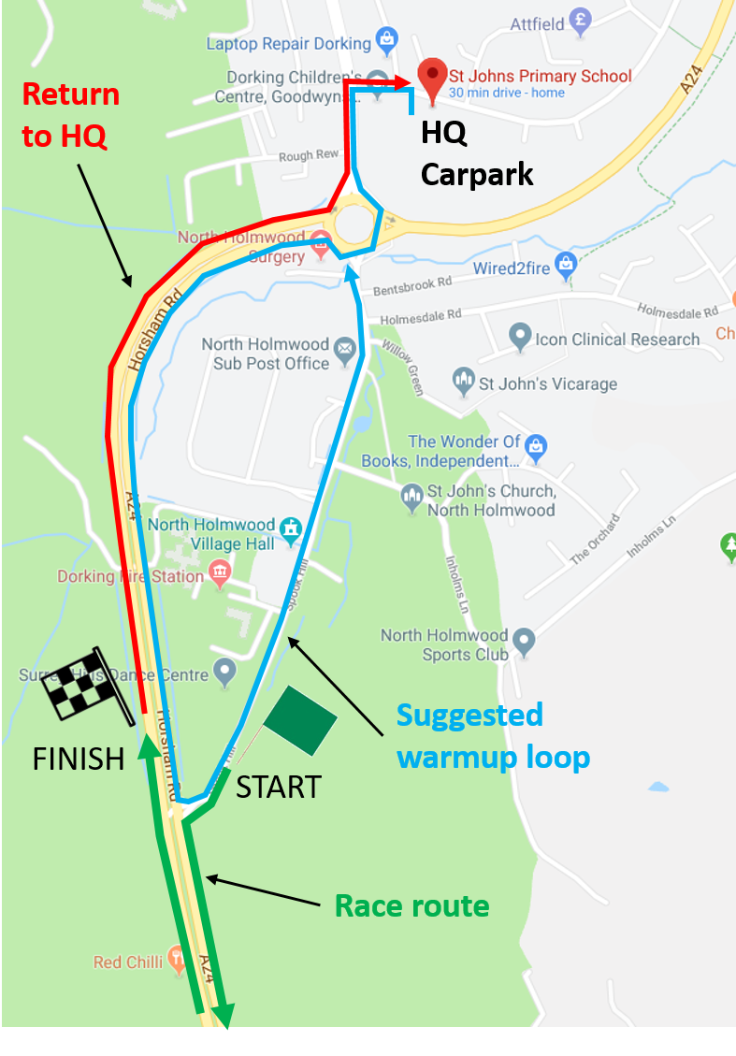

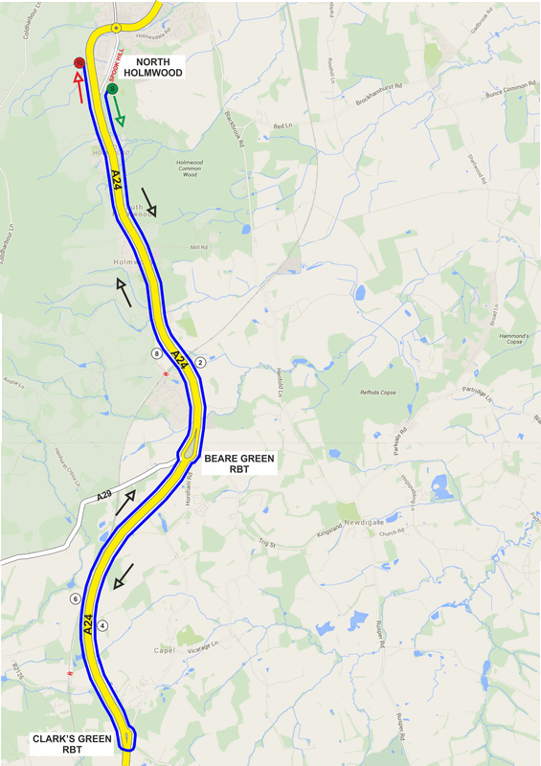
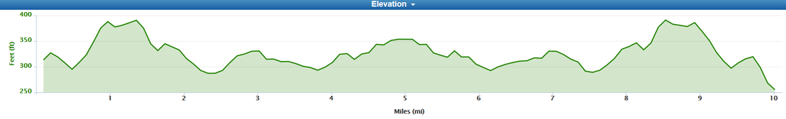

NUMBERS MUST BE FIXED BELOW WAIST

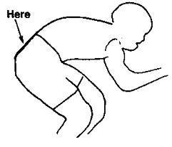

NO TIME MAY BE RECORDED IF NUMBER IS NOT CORRECTLY POSITIONED.

